Introduction-to-R.R

jessica

2025-01-16

x <- 1:50  
plot (x, sin(x))

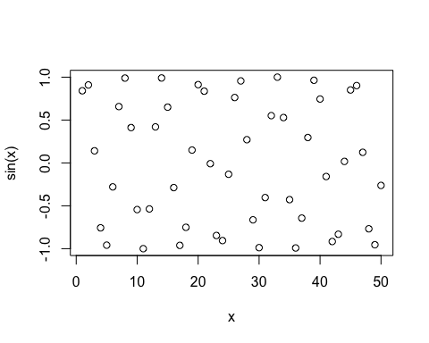

#Make this nicer   
plot(x, sin(x), col="purple", type="l", lwd="3")

